Section 1. Background & Current State
- Establishes business context and importance of why this plan was created.
- What is the current situation? Where do things stand today? Provide context for the rest of this Plan.
- Have you gathered and verified facts – not just data and anecdotes – to clearly understand the current situation?
- Where are you now as a company?

Section 2. Goals & Objectives
- Why do you want to do this?
- What do you hope to achieve?
- What are the current major business goals and how does this implementation tie into or enable those goal?
- Do existing KPIs support this implementation, or will you need new/additional?
- Do you have a mix of leading as well as trailing indicators?
- Expect to revise this section as you refine your thoughts in subsequent sections.

Section 3. Engagement: Key Stakeholders & Change Agents
- All leaders/execs are important in leading change, but who are the lynchpins that will take accountability?
- Who are the champions (can be determined later, or as time goes on)
- Who has enabling skillsets that will be valuable and enhance the implementation (can be determined later or as time goes on)?
- Map out key stakeholders (leaders, employees, teams, external parties).
- Understand their concerns, interests, and levels of influence.
- Assess the readiness for change within different stakeholder groups.
- What incentives will you create to speed the change being implemented?
- Roles/Responsibilities of key Leaders
- What incentives (formal and informal) currently reward the old way of working? How will you address these?
- How will you identify when someone is struggling with changes before they revert to old habits?

Section 4. Strategy & Approach
- Decide on the scope of implementation (e.g. company wide, department specific, process drive).
- What level of intervention/training will you have (e.g. You could have communication only for some minor changes, but those that are more difficult require training, follow-up training, coaching/mentoring, etc.)
- What is change management model(s) you want to follow? One guide is at right. The Lean Community also uses the “Road the Mastery.
- What are the strengths of this approach and what are some of the weaknesses or pitfalls to lookout for?
- Identify Feedback Mechanisms
- What specific resistance do you expect from field vs. office personnel, and how will each be addressed differently?
- How will you demonstrate early wins that matter to skeptics?
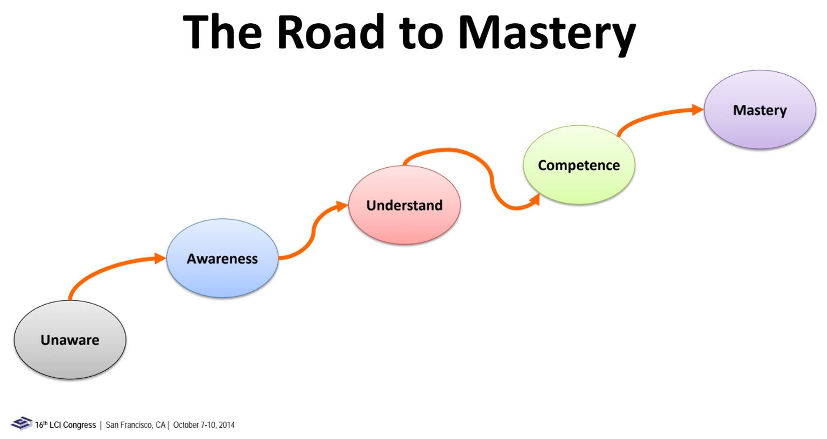
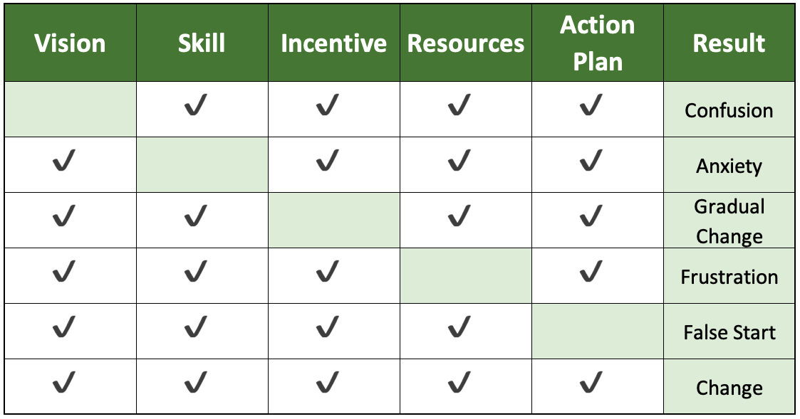
Section 5. Communication Plan
- What is the message you want to communicate to your organization about this implementation?
- Does the message get tailored for different audiences?
- What are the different communication channels you will use (e.g. All hands meetings, email blasts, trainings, posters, special events, etc.)
- How will you ensure consistent messaging from leadership and through the organization??
- How can you share what your company and individuals learn as they work to achieve the goals and objectives?
Section 6. Training & Implementation
- What skills and knowledge are needed to meet the goals and objectives?
- Do/How do these differ for different groups or audiences? How do different roles prefer to learn? (hands-on vs. classroom vs. peer examples). What will convince your most skeptical superintendent that this isn't just another 'office initiative?
- What resources are needed to ensure implementation is well supported and frustration free?
- Is there a phasing or rollout sequence?
- What are the considerations for scaling this implementation?
Section 7. Sustain, Check & Adjust
Refocus a lens forward rather than backward. We want be anticipatory so we can help ensure that the implementation succeeds.
- When should this Plan be reviewed or revisited? Is there a clear time horizon for determining success on our goals and objectives?
- When will this plan next be updated?
- What will you do when the first crisis hits and people want to abandon the new processes?
- How will policy, procedures and day to day operations need to change? Who will champion the codifying of these efforts?

General Notes
- The format for and sections of an A3 are not the same for each A3. A3 is a scientific process of learning, not a form. Above are possible sections to include in an A3. As the A3 progresses sections may be added or deleted.
- A3 should be thought of as a Story Board – include graphics (diagrams, sketches, graphs, charts, histograms)
  - Avoid long narratives.
  - It is Ok to write it out by hand. Expect multiple iterations.
- An A3 should tell a story that anyone can understand. There is a beginning, middle, and end in which the specific elements are linked, sequential, and causal.

